**ASSIGNMENT 2(STUDENT INFORMATION SYSTEM)**

1) Create the database named "SISDB"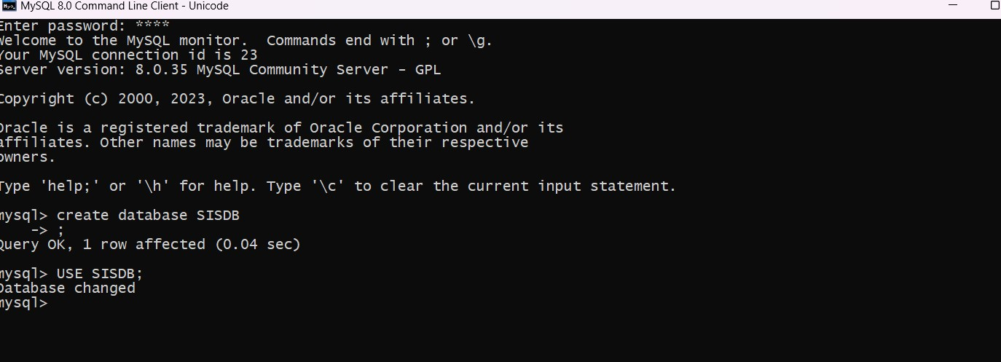

2) Define the schema for the Students, Courses, Enrollments, Teacher, and Payments tables based

on the provided schema. Write SQL scripts to create the mentioned tables with appropriate data

types, constraints, and relationships.

a. Students

b. Courses

c. Enrollments

d. Teacher

e. Payments

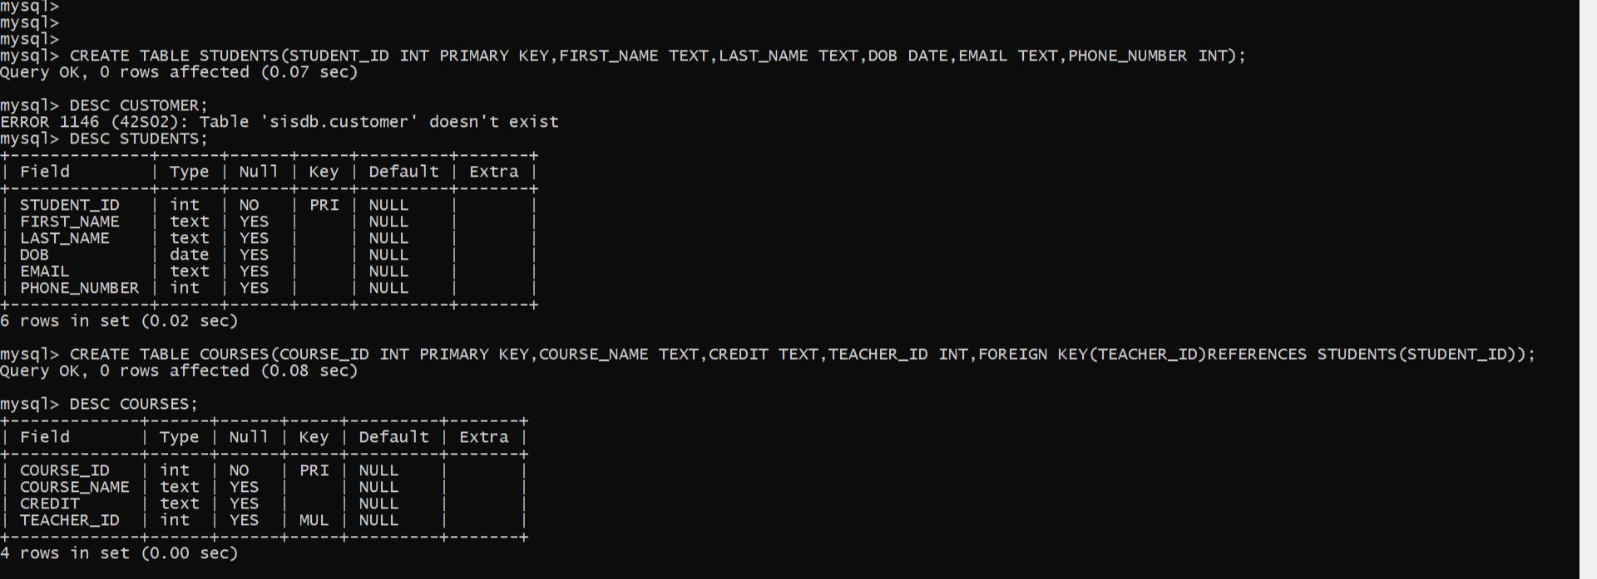

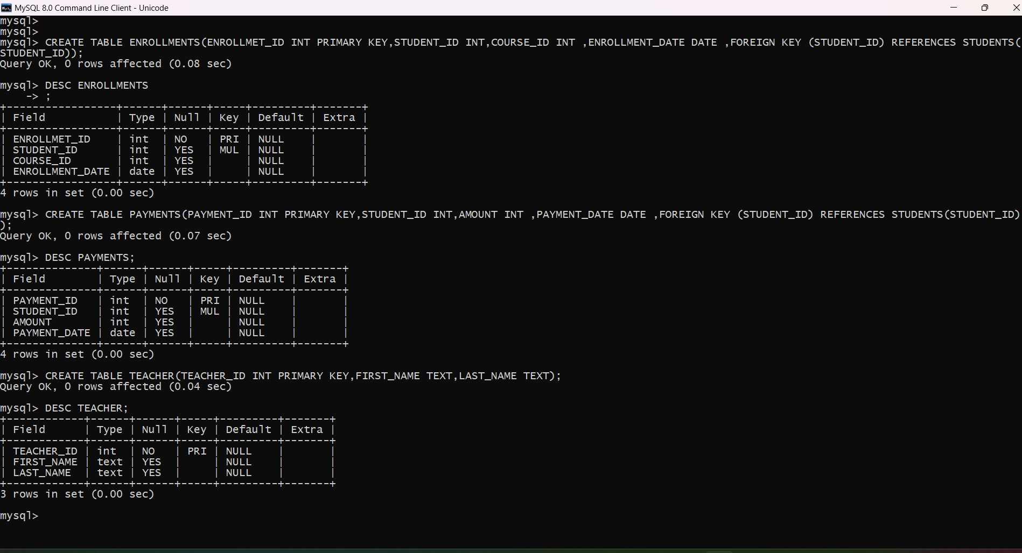

3.  Insert at least 10 sample records into each of the following tables.

i. Students

ii. Courses

iii. Enrollments

iv. Teacher

v. Payments

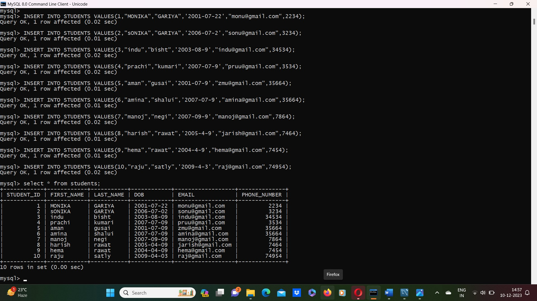

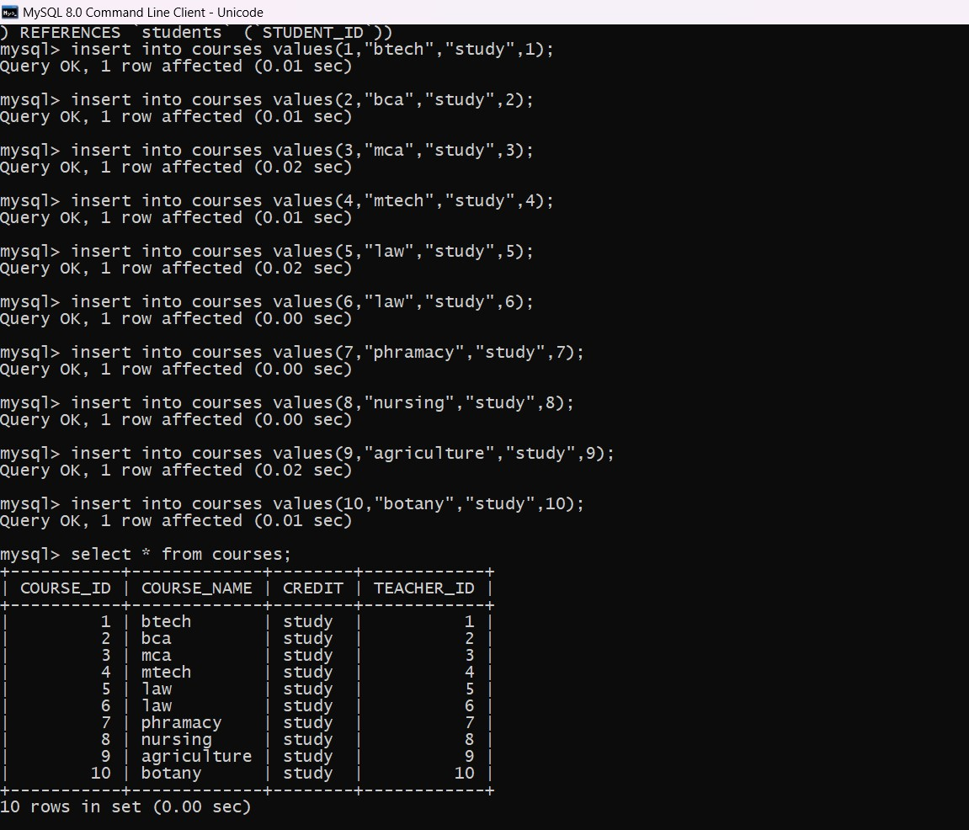

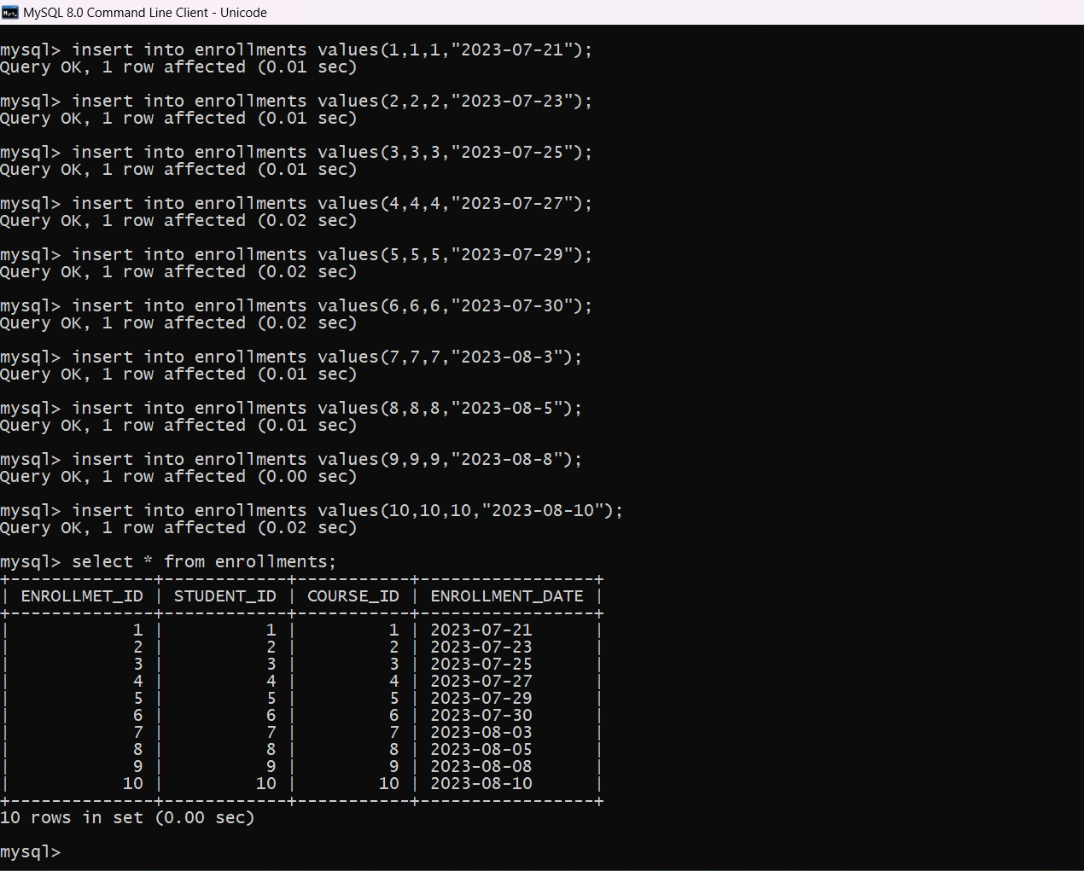

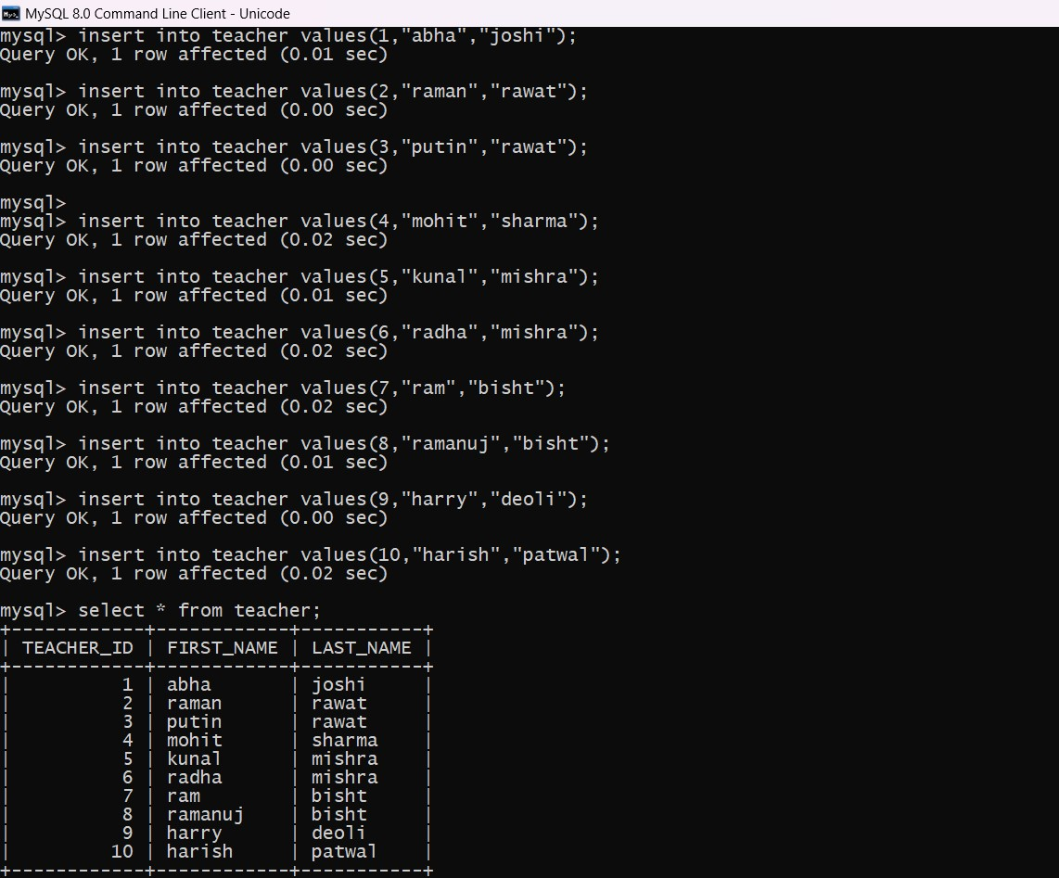

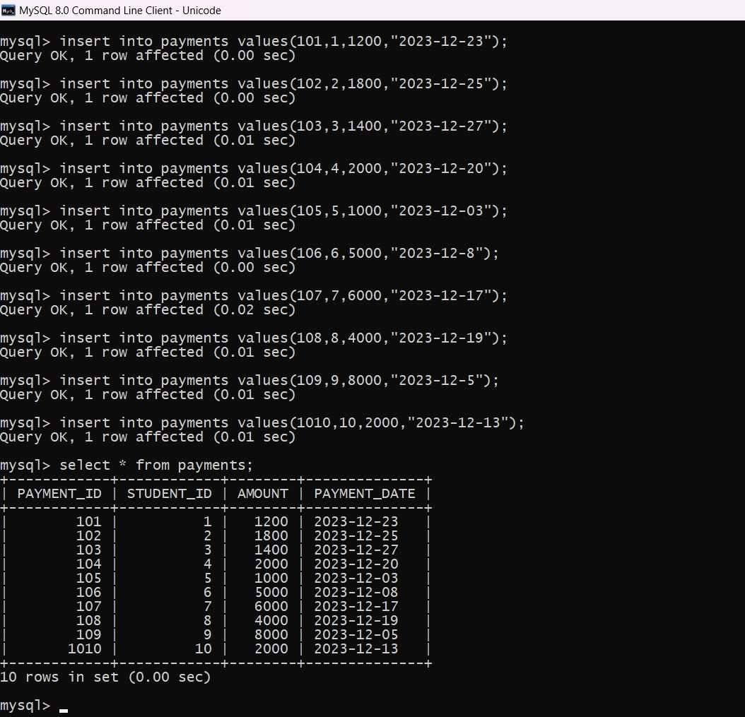

Task 2

1. Write an SQL query to insert a new student into the "Students" table with the following details:

a. First Name: John

b. Last Name: Doe

c. Date of Birth: 1995-08-15

d. Email: [john.doe@example.com](mailto:john.doe@example.com)

e. Phone Number: 1234567890

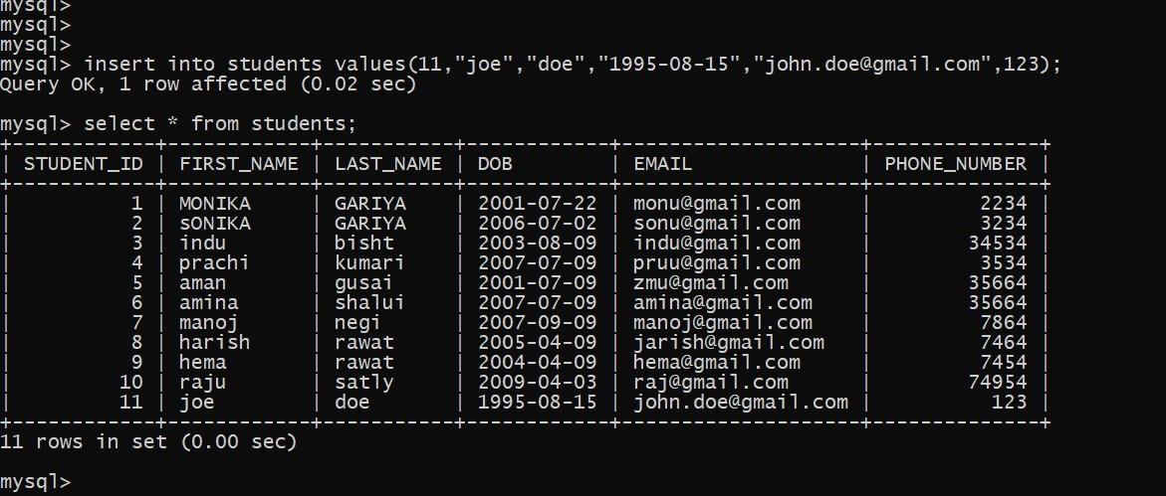

2)update the first name of a specific teacher.

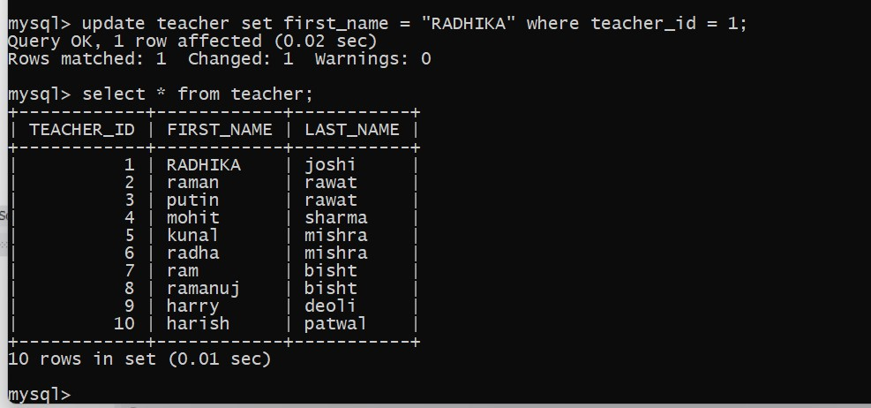

3)write an sql query to delete a specific enrollment record from the enrollments table select an enrollment record based on the students and courses.

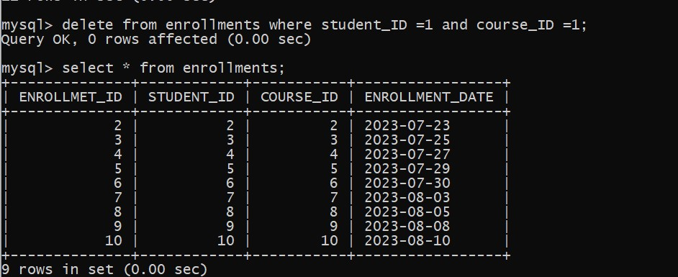

4)update the courses table to assign a specific teacher to a course.choose any course and teacher from the respective table.

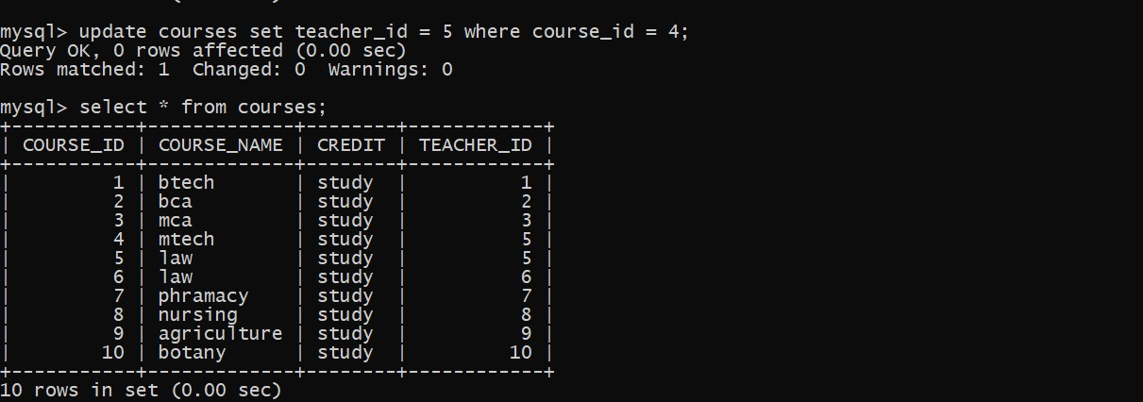

5)delete a specific students from the “students” table and remove their enrollment records.

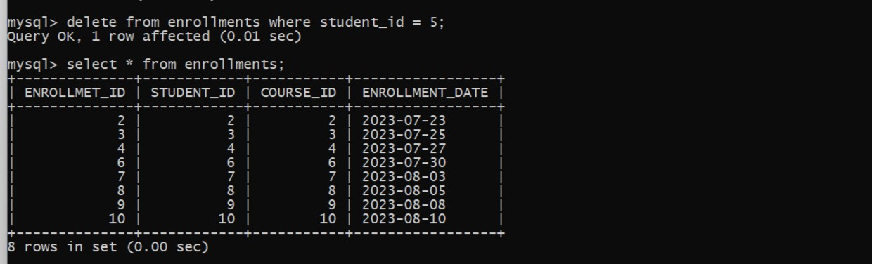

6)update the payment amount for a specific payments record in the “payments” table,choose any payments record and modify payment amount.

